African Union Member States Adopted Unified Position on the Recovery of Illicit Assets
Feb 19, 2020

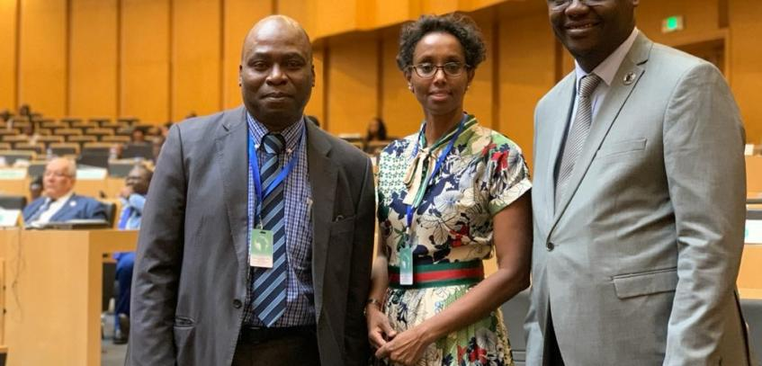
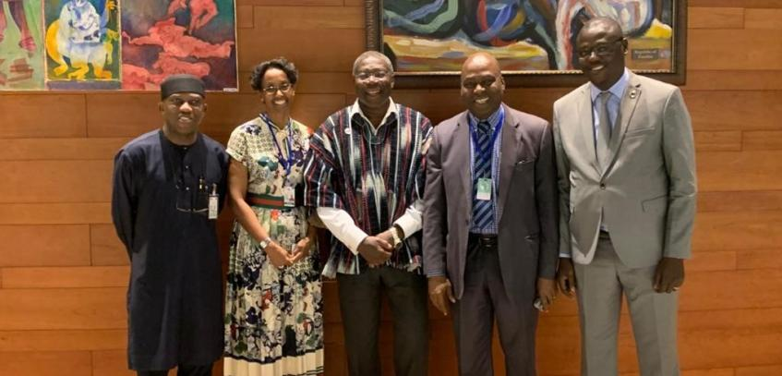
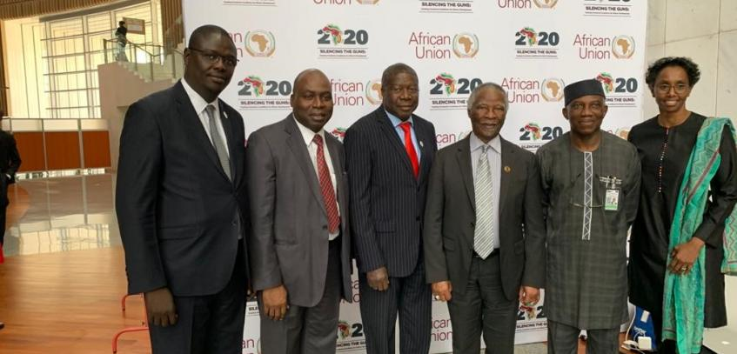
Arusha, 11 February 2020
Proposed by the government of the Federal Republic of Nigeria, the Common African Position on Asset Recovery (CAPAR) was unanimously adopted by the Heads of State and Government of the African Union at their 33rd Assembly in Addis Ababa.
The CAPAR is the bedrock for our continent’s legal instrument and technical framework for negotiating the return of our stolen assets and illicit capital flights, taken illegally out of our shores and hosted in foreign jurisdictions.
The development of this policy instrument was spearheaded by African Union Champion for Anti-Corruption, President of the Federal Republic of Nigeria and his government, the African Union Commission and the African Union Advisory Board on Corruption with the support of the members of the Consortium to Stem Illicit Financial Flows (IFFs) from Africa. The Secretariat of the AU High Level Panel on Illicit Financial Flows from Africa, the Coalition for Dialogue on Africa (CoDA) constituted the Working Group that provided technical support to the development of the guidelines. The group will also guide the necessary actions for the successful popularization and implementation of the CAPAR

