Country Review Mission for Arab Republic of Egypt
May 25, 2023
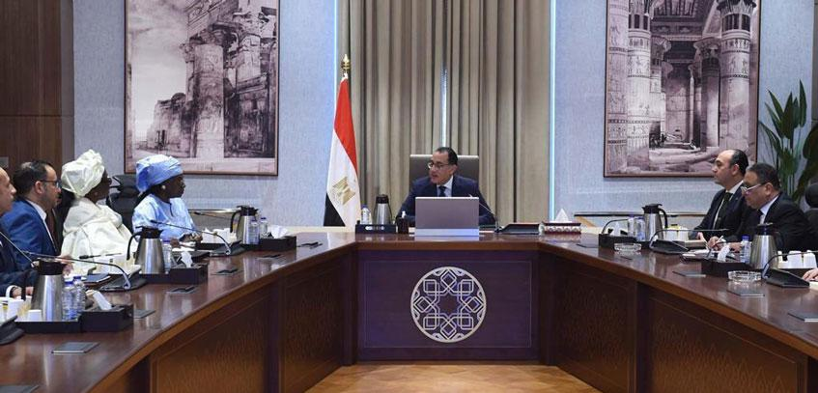
SHARE
The African Union Advisory Board against Corruption (AUABC) recently concluded a Country Review Mission to the Arab Republic of Egypt. The Review Mission, which was conducted from 15th to 18th May, 2023 was meant to assess the implementation of the African Union Convention on Preventing and Combating Corruption (AUCPCC) by Egypt as a State Party to the Convention.
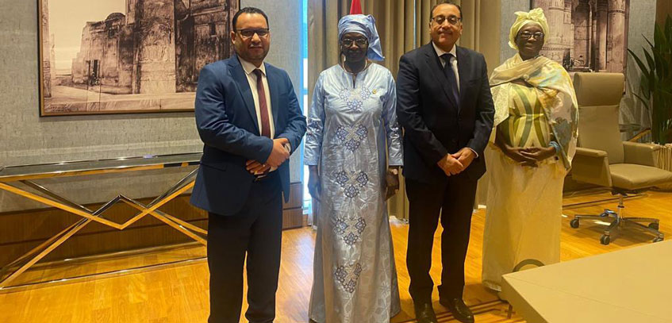
In this regard, the AUABC Delegation, which was led by the Chairperson, Hon. Seynabou Ndiaye Diakhate had discussions with different stakeholders concerned with the fight against corruption including the Administrative Control Authority (ACA), which is the lead Agency. The Delegation also visited the Egyptian Anti-Corruption Academy (EACA), which offers different anti-corruption programmes.
Further, the Chairperson and other Board Members also paid a courtesy call on the Prime Minister during the Review Mission.
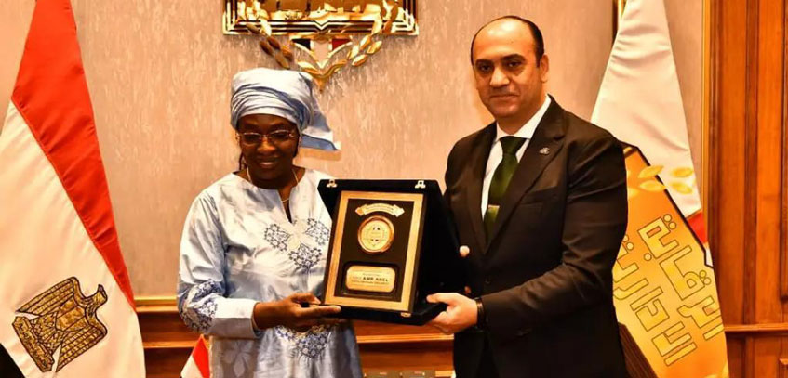
Other Board Members in the Delegation included the Board Rapporteur, Hon. Marthe Dorkagoum Boularangar as well as Hon. Tarek Mustafa Elhatab, who is the Country Rapporteur for Egypt. Hon. Zahra Kamal Khaled, a Board Member based in Cairo, Egypt was also able to join the Delegation. Three staff from the Secretariat were also part of the Delegation.
The AUABC Delegation learnt very valuable lessons and perspectives with respect to the fight against corruption in the Arab Republic of Egypt which will go a long way in enhancing the overall fight against corruption on the continent.

